Tableau Project 2

Analysis Tasks

1. Use the Saved Sample – Superstore dataset.
2. Create a bullet chart with Category and Segment dimensions and Sales measures.
3. Blend the data with the Saved Sample - Sales Target data set to bring in the Sales Target measure.
4. Color code the chart to identify Categories and Segments that are above or below target.
5. Add the year of sales to the view to identify trends and outliers.
6. Add a filter so that the user can select one, more than one, or all years.
7. Create a dashboard with this view.
8. Download the datasets from: <https://github.com/Simplilearn-Edu/Tableau-Datasets/tree/master/Project%202>
9. Load the two datasets, Sales_Target & Sample – Superstore into Tableau
10. Drag Category to columns , OrderDate and segments to rows from the Sales_Target

And Sales from the Sample_Superstore to columns for analysis

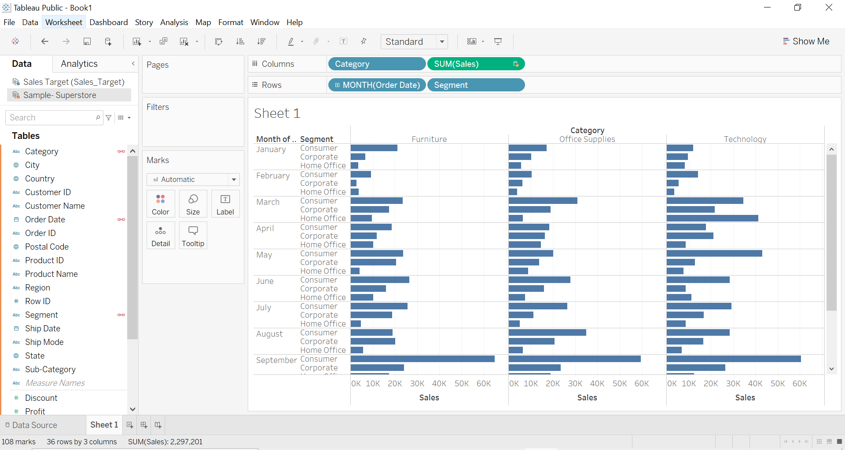

1. Select Sales Target (Sales Target) from Sales_Target.csv and go to ShowMe Panel select Bullet Graph
2. Use the function swap reference lines as Tableau is confused of the dimensions used

e.g, primary field should be SUM(sales) instead of SUM(Sales Target (Sales target))

Use the function Swap Reference Lines to swap the primary field to SUM(Sales) and the secondary field to SUM(Sales Target (Sales target)).

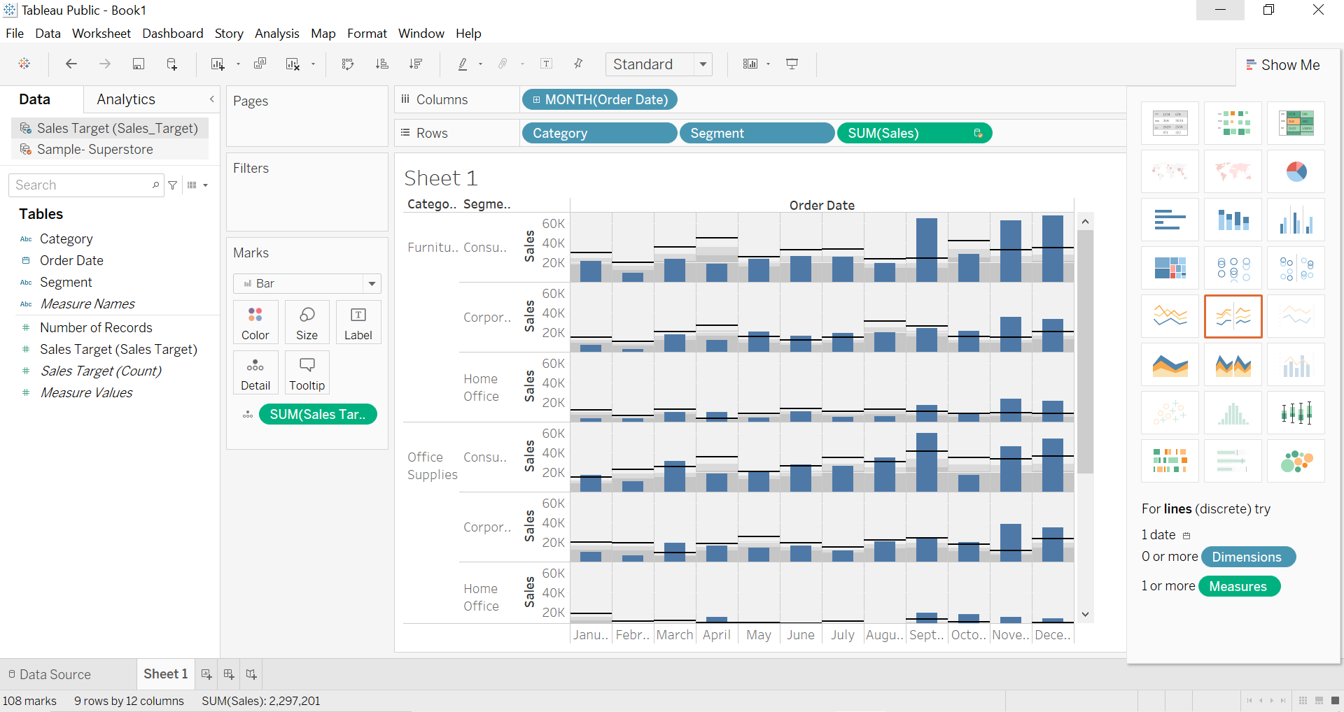

1. Drag Order Date into filters and select years and click show filter

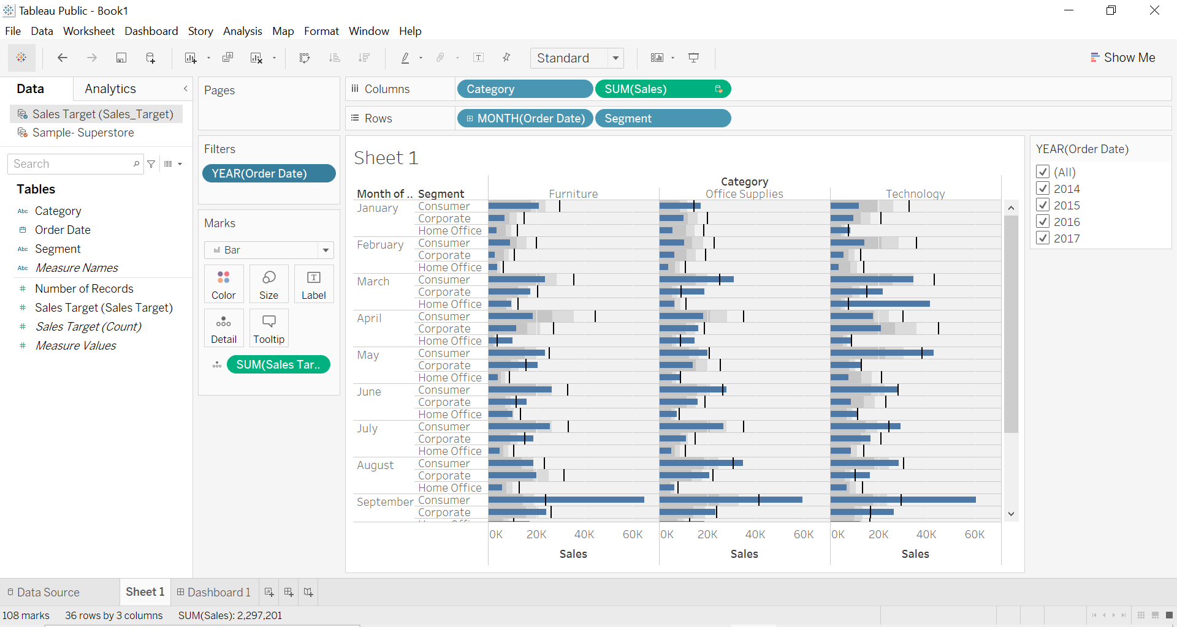

1. Create a calculated field: Sales Above target Sales and drag into color.

Change the default colour of orange and blue into green and red.

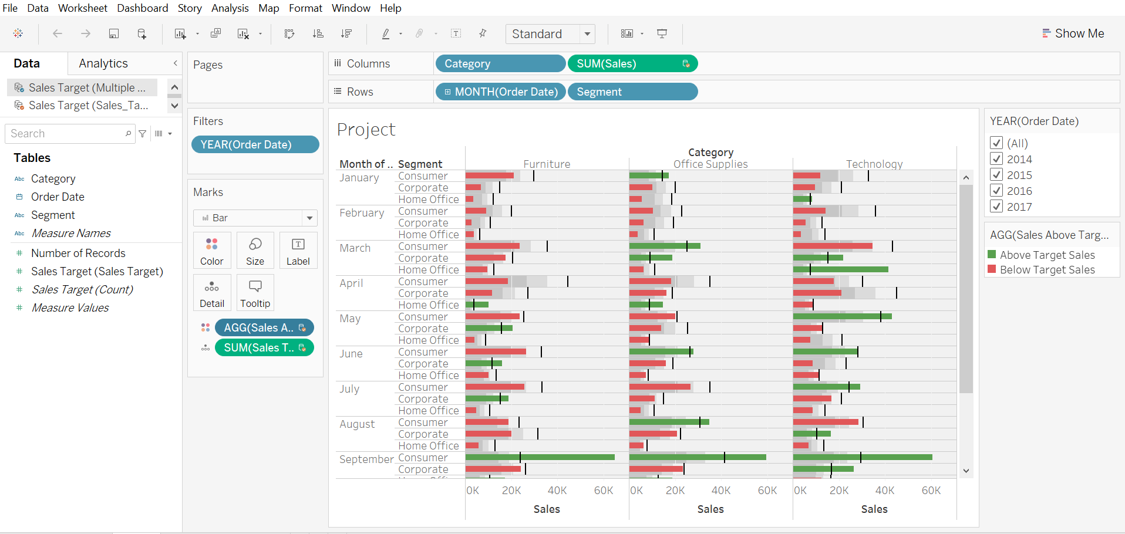

1. Input the worksheet into dashboard

